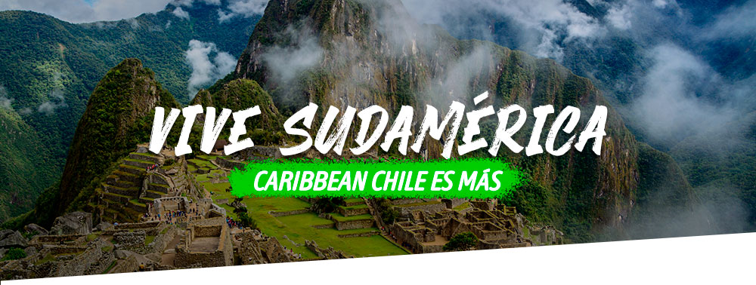

|  |  |  |  |
| --- | --- | --- | --- |
|  | */*  **1 días / noches** | |  |
| $US**0** |
| **Por Persona en Habitación Doble** |  |
|  | |
| ***Programa*** *Incluye* | |

*Tarifas del* ***Programa***

|  |  |  |  |  |  |  |  |  |
| --- | --- | --- | --- | --- | --- | --- | --- | --- |
| **HOTEL** | **DESDE** | **HASTA** | **SGL+** | **DBL** | **TPL** | **CHD1** | **CHD2** | **FAM** **2AD + 2CHD** **(Por Persona)** |

*Itinerario del* ***Programa***

*Condiciones del* ***Programa***

*Datos del* ***Contacto***

* +56/2 2993 4200
* Santa Magdalena 75 Of 612, Providencia - Chile

## [www.caribbeanchile.cl](http://www.caribbeanchile.cl)

### <https://www.facebook.com/CaribbeanChileCL>

#### <https://www.instagram.com/CaribbeanChileCL>